****GREENWOOD PUBLIC SCHOOL, ADITYAPURAM**

**OUR MOTTO - DEVELOPMENT WITH DELIGHT**

**SYLLABUS FOR THE MONTH OF JANUARY (2019-20)**

**CLASS-NURSERY**

|  |  |  |  |
| --- | --- | --- | --- |
| **SUBJECTS** |  | **ACTIVITY+USE OF ICT** | **PARENTS INVOLVEMENT** |
| **English** | **Oral (Rhymes):** I have a little nose, Two little hands, Baa, Baa Black sheep.  **Written** :Alphabets- U to Z  **Workbook:** Page No. 28-45  **Recognition Alphabets:** A to Z | C:\Users\123\Desktop\TC\cartoon-kids-with-abcdef-letters-vector-19913776.jpgC:\Users\123\Desktop\images\maxresdefault.jpg | Help your child in learning rhymes and written work |
| **Hindi** | **Oral : dfork,¡ &** हरी-हरी , इंद्रधनुष, मेरी गुड़िया  **Written** : स्वर **अ से अ: तक**  **Recognition Alphabets:** स्वर अ ls v% तक  **Workbook:** Page no 30-38 | C:\Users\123\Desktop\images\hqdefault.jpg | dfork,sa ;kn djok,Wa rFkk o.kksaZ dh igpku fp=ksa +}kjk djok,W! |
| **Maths** | **Oral :** Counting 1-50  **Written**: 15-20  **Recognition Digit :**1-20  **Workbook:** Page no 28-36 | C:\Users\123\Desktop\images\maxresdefault (5).jpg | Motivate your child in learning tables. |
| **Drawing** | Page no 21-24 |  |  |
| **G.K.** | **Oral:** Water animals, Vehicles, Flowers names. | PPT on Body parts and pet animals.  C:\Users\123\Desktop\images\pics-of-cartoon-fruits.jpg | Help your child to recog. the super Heroes. |
| **V.E.** | Be regular to school, Value time. | C:\Users\123\Desktop\images\school-building-md.pngPPT on School | Talk to your child about the school and your child’s friends. |
| **Physical Education** | Fun Games |  | Take your child to a park and play some games. |
| **Language Development** | Left, Right, Sit Straight, Get in a line, Come forward , Go backward, Old, New. |  |  |
| **Conversation** | **English Conversation**  **1. Which is our National Animal?**  Ans-Tiger.  **2. Who is the Tallest Animal?**  Ans-Giraffe.  **3. Which is Our National Bird?**  Ans-Peacock.  **4. Which is Our National Song?**  Ans- Vande Mataram.  **5. Which is Our National Flower?**  Ans- Lotus. | **Hindi Conversation**  **प्रश्न 1- हमारा राष्ट्रीय पशु कौन सा हैं?**  **उत्तर - चीता |**  **प्रश्न 2-** **सबसे लम्बा जानवर कौन सा हैं?**  **उत्तर -** जिराफ |  **प्रश्न 3-** **हमारा राष्ट्रीय पक्षी कौन सा हैं?**  **उत्तर** - **मोर |**  **प्रश्न 4** हमारा राष्ट्रीय गीत कौन सा हैं?  **उत्तर** - वंदे मातरम्  **|**  **प्रश्न 5** हमारा राष्ट्रीय फूल कौन सा हैं?  **उत्तर** - कमल **|** | Help your child in learning Conversation Que/Ans |

**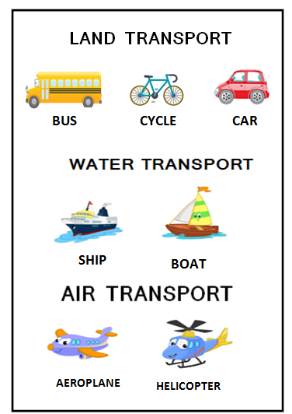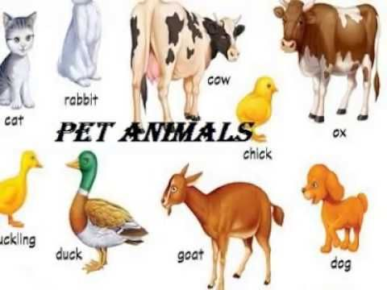**

**Stars of The Month**

****

1. Aashi Singh Rathod.

2. Aditya Rajput.

3. Bhumika Singh.

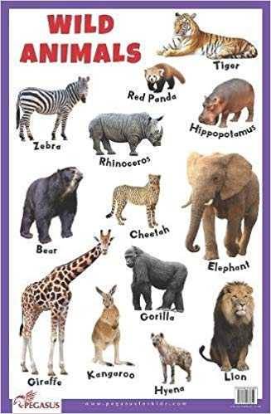

****GREENWOOD PUBLIC SCHOOL, ADITYAPURAM**

**OUR MOTTO - DEVELOPMENT WITH DELIGHT**

**SYLLABUS FOR THE MONTH OF JANUARY (2019-20)**

**CLASS-L.K.G**

|  |  |  |  |
| --- | --- | --- | --- |
| **SUBJECTS** |  | **ACTIVITY+USE OF ICT** | **PARENTS INVOLVEMENT** |
| **English** | **Oral:-Rhymes-** Little Bo-Peep, Vegetables, Engine- engine number nine, Tom-Tom the Piper’s son.  **Reading –** sounds of vowel “*O*” and “U” , use of ‘This’ and ‘That’, use of ‘And’ one/many.  **Written:** sounds of vowel “*O” and “U” ,* dictation use of ‘This’ and ‘That’, Use of ‘and’ one/many.  **Vocabulary Building:** Run, fun, Face, Hobby, Garden, Railway station. | **C:\Users\123\Desktop\images\45092984-stock-vector-happy-school-kids-with-alphabet-blocks.jpg** | **Help your child in learning rhymes and written work** |
| **Hindi** | **मौखिक**: **कविताएँ –** एक - दो-तीन-चार, चूँ-चूँ, अहा टमाटर बड़ा मजेदार,  आलू बोला  **पठन- पाठन**- चार अक्षर के बिना मात्रा वाले शब्द , एकवचन / बहुवचन , मात्रा ज्ञान  **Written:** चार अक्षर के बिना मात्रा वाले शब्द , दो-तीन और चार शब्दों से बने वाक्य , मात्रा ज्ञान, श्रुतलेख | **C:\Users\123\Desktop\images\images.jpg** | dfork,sa ;kndjok,WarFkko.kksaZ dh igpkufp=ksa +}kjkdjok,W! |
| **Maths** | **Oral:** Counting from 151-200, Tables 2-5, Number names 16-20  **Activity:** (Unit-7 and 8)  **Written: Counting** 151-200, Table of 5, Number names16-20, Subtraction, shapes, Time, dictation. | **C:\Users\123\Desktop\images\download (1).jpg** | **Motivate your child in learning tables.** |
| **G.K. Oral** | Cartoon Characters, seasons, Different types of Indoor and Outdoor games. | **C:\Users\123\Desktop\images\800px_COLOURBOX20120355.jpgC:\Users\123\Desktop\images\download (4).jpg** | **Tell your child about different festivals celebrated in India** |
| **Drawing** | Page No. 16-24 |  |  |
| **V.E.** | Wish and obey your elders, Parents and Teachers. |  | **Motivate your child to speak the truth.** |
| **Physical Education** | Fun Games |  | **Take your child for a nature walk.** |
| **Language Development** | Help me, Take care, Give this, Take this. |  |  |
| **Conversation** | **English Conversation**  **Q.1 When do we celebrate Republic Day?**  Ans- 26th January.  **Q.2 Name the National Flag of India?**  **Ans-** Tricolour.  **Q.3 What is the National Song of India?**  Ans- Vande Mataram.  **Q.4 When was the First Republic Day celebrated?**  Ans- 26th January 1950.  **Q.5 Which season is extremely dry and cold?**  Ans-Winter. | **Hindi Conversation**  **प्र1: गणतंत्र दिवस कब मनाया जाता हैं?**  **उत्तर-** **गणतंत्र दिवस 26 जनवरी को मनाया जाता हैं |**  **प्र2: गणतंत्र दिवस क्यों मनाया जाता हैं?**  **उत्तर-** **इस दिन हमारे देश का संविधान लागू हुआ था |**  **प्र3: हमारे देश का राष्ट्रीय गीत कौन सा हैं?**  **उत्तर-** वंदे मातरम्  **|**  **प्र4: लोहड़ी का त्योंहार धूमधाम से कहाँ मनाया जाता हैं?**  **उत्तर-** **पंजाब में |**  **प्र5: पतंग किस त्योंहार पर उड़ाई जाती हैं?**  **उत्तर**- **पतंग मकर संक्रांति पर उड़ाई जाती हैं |** | |

** Merry Christmas **

**Stars of December Month**

**(LKG-B)**

**1.** Aditya Parmar

**2.** Abhishek Gurjar

**3.** Khushi Singh

**4.** Rudra Kaurav

**Stars of December Month**

**(LKG-B)**

**1.** Sargun Tiwari

**2.** Ahana Sikarwar

**3.** Laxmi Bohare

**4.** Harshvardhan Sharma

**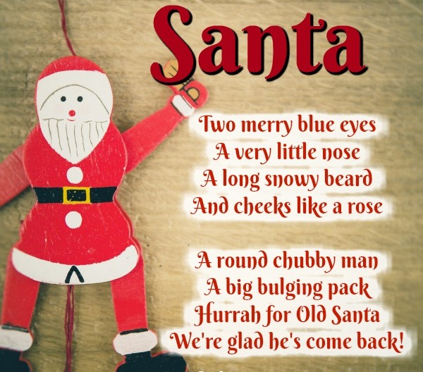**

****GREENWOOD PUBLIC SCHOOL, ADITYAPURAM**

**OUR MOTTO - DEVELOPMENT WITH DELIGHT**

**SYLLABUS FOR THE MONTH OF JANUARY (2019-20)**

**CLASS-U.K.G**

|  |  |  |  |
| --- | --- | --- | --- |
| **SUBJECTS** |  | **ACTIVITY+USE OF ICT** | **PARENTS INVOLVEMENT** |
| **English** | **Oral:-Rhymes-** Vroom-Vroom, Each has a house.  **Written:** Noun, Page-36-44, Use of ‘We are’, ‘they are’, Use of ‘in front of’ ‘near’, ‘On’ ‘In’, Use of ‘Under’ and ‘Behind’, Use of ‘Where’ ‘Who’ ‘Has’ ‘Have’ ‘How many’  **Vocabulary Building:** Field, Fire station, Forest ,Frog, Indigo | **C:\Users\123\Desktop\images\45092984-stock-vector-happy-school-kids-with-alphabet-blocks.jpg** | **Help your child in learning rhymes and written work** |
| **Hindi** | **मौखिक**: **कविताएँ-** फूलो के नाम  **लिखित:** **स्वरों को मात्रा से मिलाना , बारहखड़ी , पालतू पशु , जंगली पशु ,** फूलो के नाम, हिंदी गिनती एवं निबंध |  **अभ्यास पुस्तिका** - पेज न. 33-50 से Rkd | | **C:\Users\123\Desktop\images\images.jpg** | dfork,sa ;kndjok,WarFkko.kksaZ dh igpkufp=ksa +}kjkdjok,W! |
| **Maths** | **Oral :** Table of 2-10, Numbers name 50-70 and counting.  **Written :** Numbers name 81-100, counting from 401-500, Reverse counting from 100-50, division and Time, Tens and Ones. | **C:\Users\123\Desktop\images\download (1).jpg** | **Motivate your child in counting objects and learning tables.** |
| **E.V.S** | **Oral –** Planets name, Vegetables name.  **Written** – The Sun, The Moon and The Stars, Planets name. |  |  |
| **G.K. Oral** | **Oral**- Young ones, Action words and In the classroom. | **C:\Users\123\Desktop\images\800px_COLOURBOX20120355.jpgC:\Users\123\Desktop\images\download (4).jpg** | **Play some indoor games with your child** |
| **Drawing** | Page no 25 to 35 |  |  |
| **Physical Education** | Fun Games |  | **Take your child for a nature walk.** |
| **Language Development** | Open your book, Draw a margin, Open a new page, Stop working and repeat it. |  |  |
| **Conversation** | **English Conversation**  **Q.1 Name 3 National festivals.**  **Ans-** Republic Day, Independence Day & Gandhi Jayanti.  **Q.2 When do we celebrate Republic Day?**  **Ans-** On 26th January.  **Q.3 How many spokes are there in Ashoka chakra?**  **Ans-** There are 24 spokes in Ashoka Chakra.  **Q.4 When do we celebrate Mahasankranti?**  **Ans-** We celebrate Mahasankranti on 14th January. | **Hindi Conversation**  **प्र1: वसंतपंचमी के दिन किस देवी की पूजा की जाती हैं?**  **उत्तर** **-** **वसंतपंचमी के दिन माँ सरस्वती की पूजा की जाती हैं |**  **प्र2: मकर संक्रांति का त्योंहार कब मनाया जाता हैं?**  **उत्तर-** **मकर संक्रांति का त्योंहार 14 जनवरी को** मनाया **जाता हैं |**  **प्र3: मकर संक्रांति के दिन कौन सा खेल लोकप्रिय हैं?**  **उत्तर-** **पतंगबाजी का**  **प्र4: गणतंत्र दिवस कब मनाया जाता हैं?**  **उत्तर-** **गणतंत्र दिवस प्रतिवर्ष 26 जनवरी को मनाया जाता हैं |**  **प्र5: गणतंत्र दिवस क्यों मनाया जाता हैं?**  **उत्तर-** गणतंत्र दिवस के दिन हमारा **संविधान लागू हुआ था |** | |

**Stars of the Month**

**(UKG-B)**

1. Veeradyumna S.Parihar

2. Aditya Tomar

3. Abhinav Asewar

4. Vaidika

**Stars of the Month**

**(UKG-A)**

1. Mohan Lodhi

2. Edal Singh

3. Asmit Kansana

4. Hardik Lodhi

**Merry Christmas** 



****

****

**Stars of the Month**

**(UKG-C)**

1. Gurdat Singh

2. Pushparaj Singh

3. Simran Kaur

4. Somya Bhadoriya